

ER/OR Scheduling Application

Tim Singel

CS5319

On Campus

I’m Tim, and the application I am building is inspired by my mothers job, as she always complains that the shift management system in place is quite lacking in flow, and especially in scale. Only allowing people to apply about a week ahead. I intend to implement these restrictions aswell, but I feel that allowing people an allotted sick-drops on shifts per month would be appropriate as well as insuring the call-list can cover the missing person.

**Project Overview:**

1. The purpose and function of my software will be a shift manager for ERs in Dallas, allowing people to make an account, login, and select one or multiple shifts to add themselves to or to review the attendees of. Aswell as this, there will be a list for “call” which is the state where Nurses must stay ready at home, for the chance to get called into the hospital due to urgency. I'm also hoping to set up a small notification center to allow people to request a cover on some shifts. This data and accounts will be made to be stored locally in a safe encrypted format. I also intend to implement the 8,10 hour shifts to the whole deal. I may make a small node server backend to handle the storage, but until then, I have had no trouble with simple mysql connections in the local java app. I may simply give myself a couple tables with no auto wipe commands in the java app, and do cross table verification on the login.
2. The Outputs and Results
   1. I first want a working GUI app that has a satisfying user flow from open to close, that allows the users to easily create a profile, login, view the shifts, apply for shifts, or simply view who's on each one.
   2. I want the data to remain independently encrypted on a sql database stored locally at the hospital of operation.
   3. I also hope that I can make the app have some sort of operational server, built on node or java, to allow the server to remain small in data size and maintain optimal speed.
   4. I intend for the list to contain the highest complexity, as it will hopefully be capable of listing the day, time, available roles, and even hopefully a hover feature to quickly view the other nurses on shift.
   5. I also hope that with only 1 selected, a person can click view to see the full info on what's happening, as in the doctors at that time, as well as potential operations for OR nurses.
3. Prototypes
   1. I first started with a simple login screen, as I hope that this will be an easy place to separate up all my account variables for easy encryption, then storage.
      1. 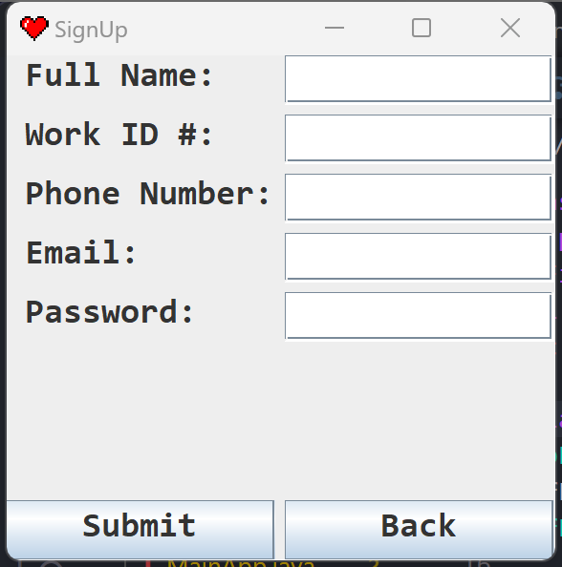
   2. After this I went straight to designing the List screen, and figuring out how to call from several JLists in one row of a JScrollPane. I may work out an ascii solution for available and full Spots down the line to show how full a shift is.
      1. One value selected to allow me to view the specifics of the one shift 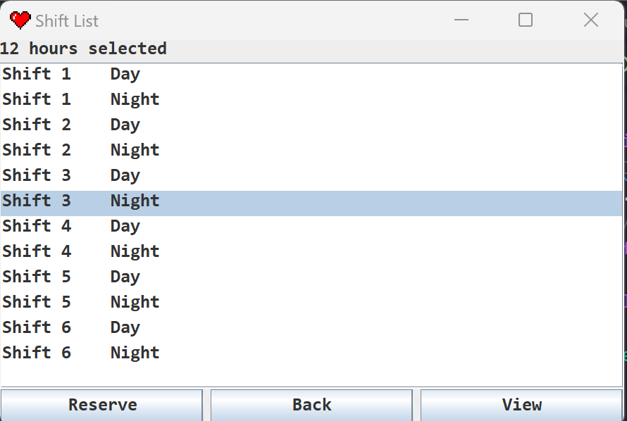
      2. Several values selected to allow me to Reserve a spot in each. (Ctrl + M1 to select multiple) also auto updates the amount of hours and the button selection.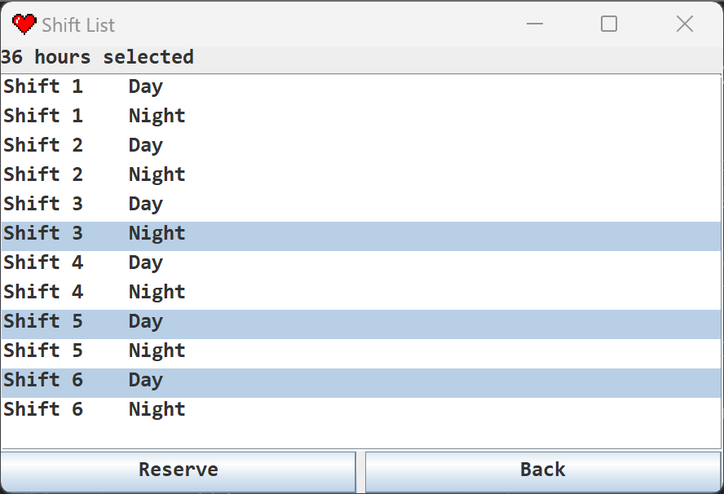
   3. I also started the individual shift Inspect feature, and I may add a feature to allow you to select a nurse from the Left row, to view all there contact information, as well as a photo of them, But I am still figuring out how to scale my photos correctly, and may have to write a java resize function to make them uniform. Also scales to include scrollbar and fit all info. I need to get some info from my Mom, to hopefully find some more features for the whole toolset.
      1. 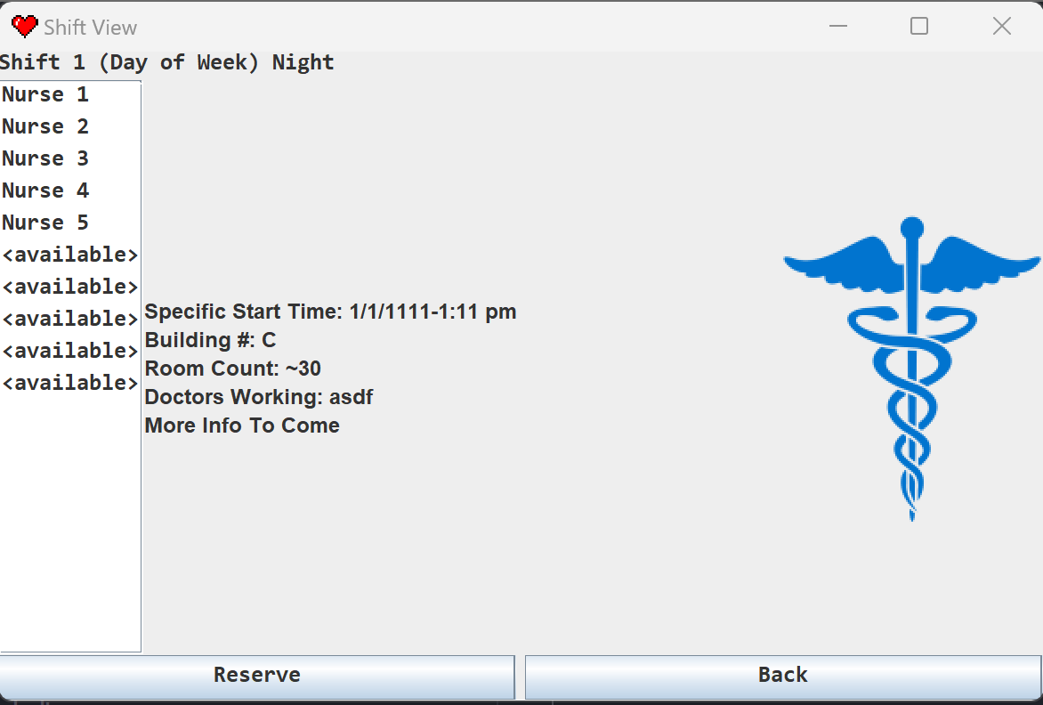
   4. Ideally you open the login which unlocks the system for you, it may be vulnerable to password steals, but this would require ssh to the system, as its all localized and secure, meaning the passwords do not exist outside of the hospital in memory. Once logged in the list will appear and allow you to scroll through all the upcoming shifts, then you can click view on as many single-selections as you want, opening a new window on the screen, as they are small, I may figure out a calendar design with the jframe style, but It will be some time before I figure this out.

**Project Design:**

1. Architecture Styles
   1. Object-Oriented Programming
      1. The entire front end will be of panels that each are represented as a single class, some panels perform more actions than others, but they are all represented in separate zones from each other. Some actions such as session verification may exist within their own objects as well.
   2. Client-Server Structure
      1. I would instead be running the process remotely and carrying the process off on a server, but I feel this is not required, and not safe for the data. There are secure safe ways to host this online, but hosting on the hospital premises means 100% stable connection and power at all times, with backup generators. Presumably this could be loaded on a work issued devices for access at home.
2. Architecture Diagrams
   1. Object-Oriented
      1. 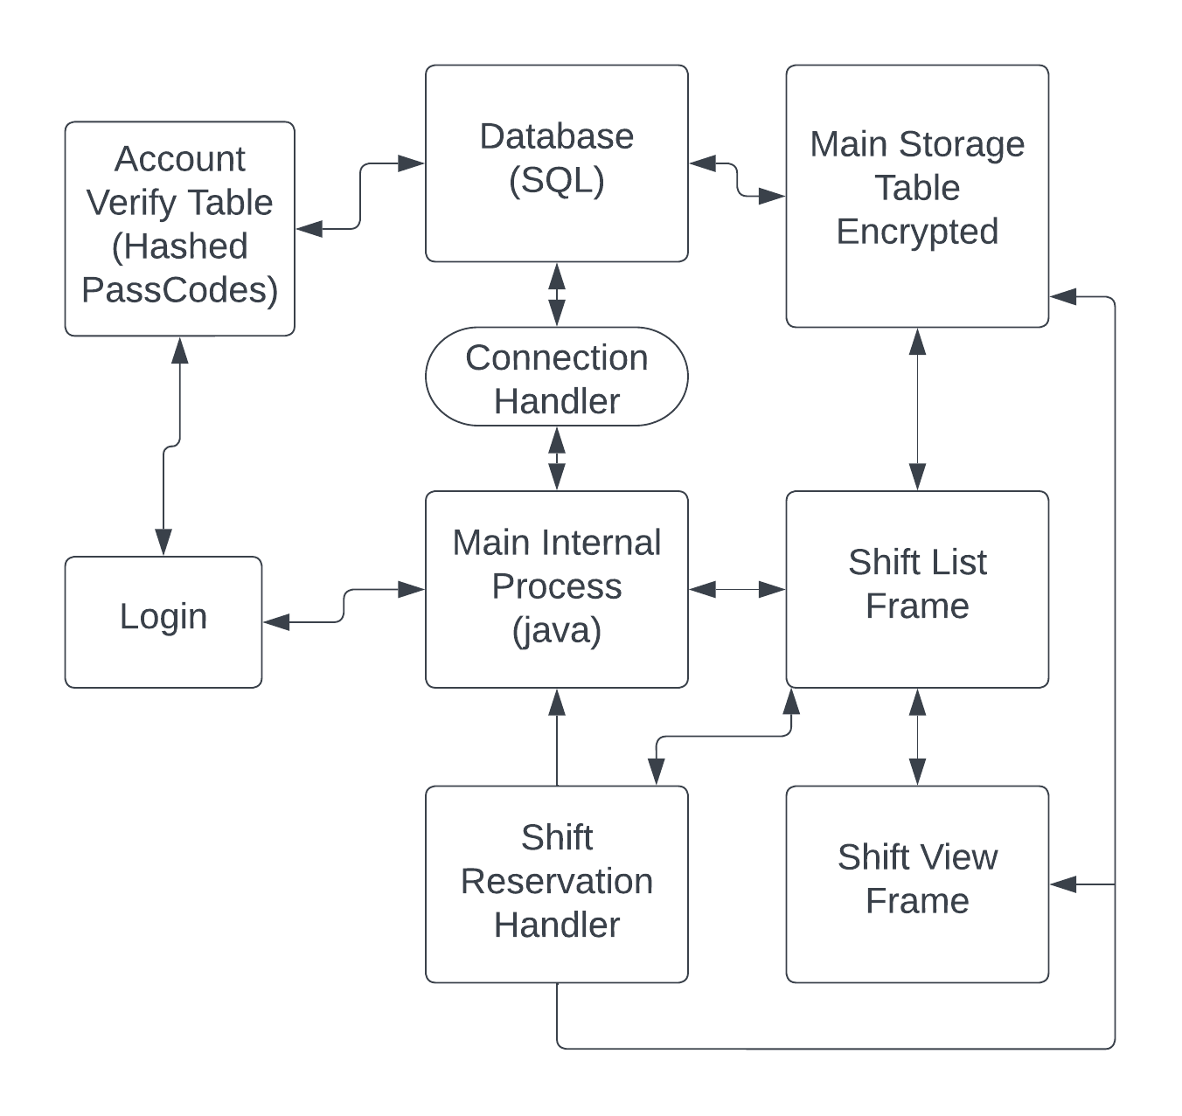
   2. Client-Server
      1. 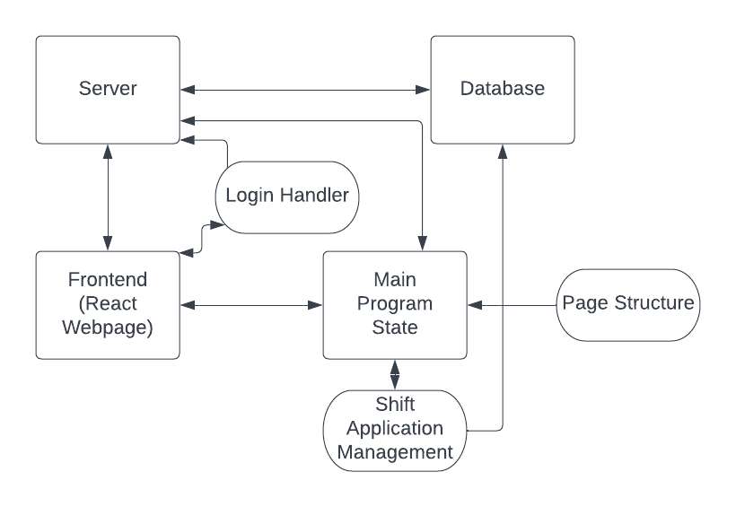
   3. Just for it to be said, I do intend to go further than this in general, but the hashing process is a bit foreign to me, I am aware of the BCrypt node fashion, but I would like to find a way to have the SQL db as the means of security, with the ssh permissions helping to secure it. I plan to update this as I go to include the hash process I end up taking.
3. I will be doing Object-Oriented local programming for the structure of the project. I feel that the local software runtime is much faster, and allows for less errors from potential async functions. The sql connection can handle most of the load if multiple instances are manipulating it.

**Project Implementation Plan:**

1. I plan to first build the whole front end using no hashing and storing values locally in memory
2. Then once the flow and features exist, I will format a SQL database to my needs, and start working on the conversion parameters for the Arrays and values coming and going to the database, so that nothing catches me by surprise.
3. Then I will work on the hashing of the data, as well as the return protocols to fix the data.
4. At this point, I will try to find more menus and features to add, but I will firstly finish the whole featureset that I first intended.